DMC sample HMI
- Remove old references.
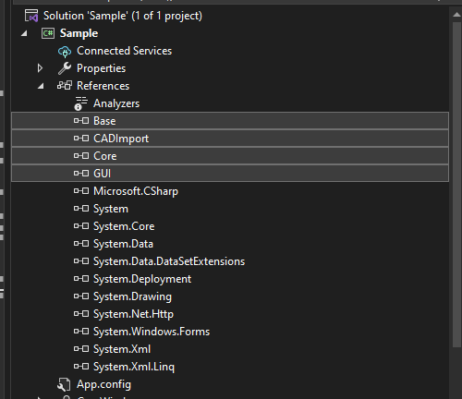

- Add new references from installed DMC version.
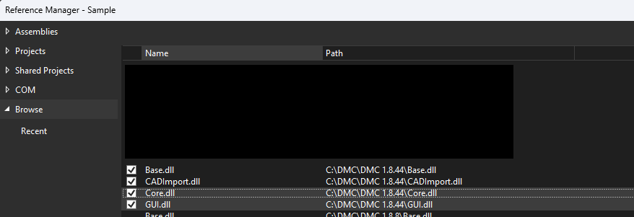

- Set project output path to installed DMC version.
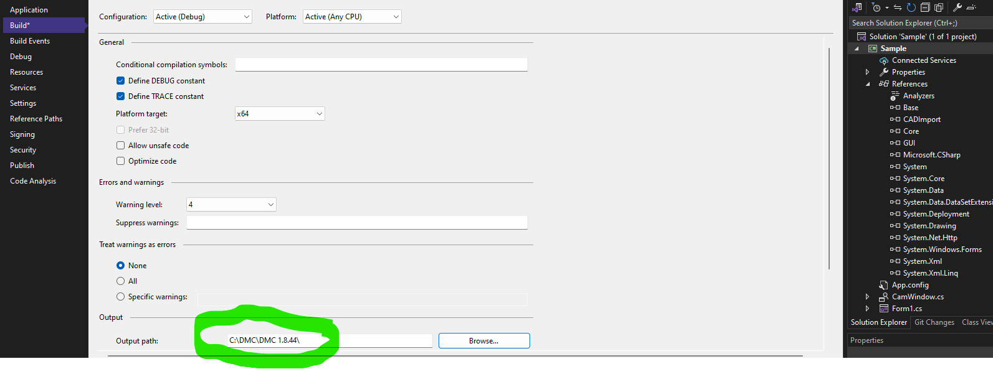
- Run project

EDIT tab. Allows to import dxf model, edit parameters, see preview window.
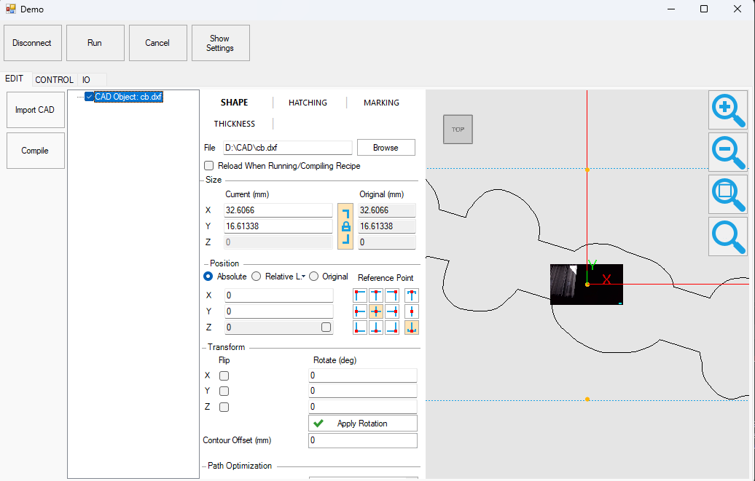

CONTROL tab. Allows to move axes in freemove and step mode. This tab includes real-time camera view
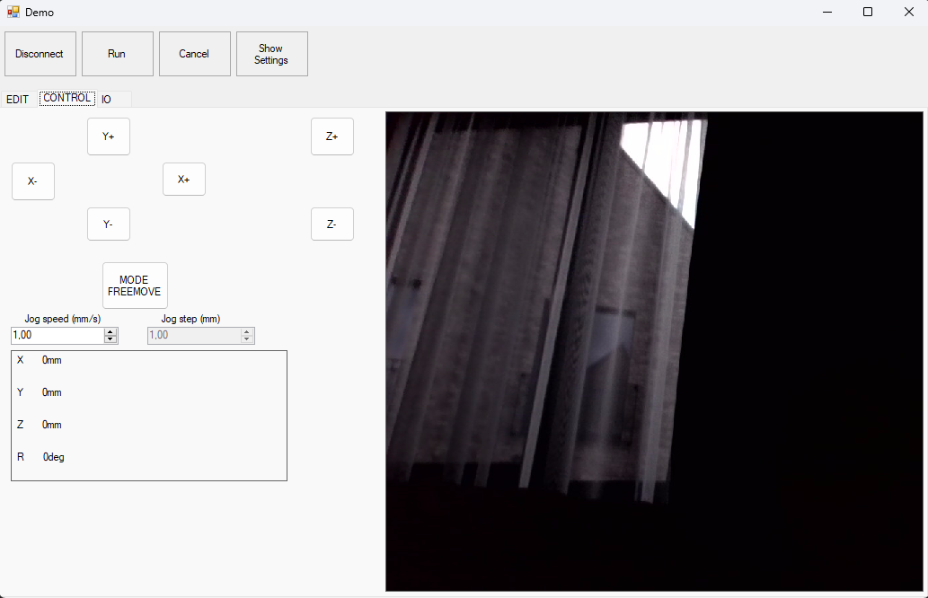

IO tab (Inputs and outputs configured in Settings->IO Tools)